**Trilogy Part III: Closing the Deal – Not Just Winning It**

**The Art of the Close**

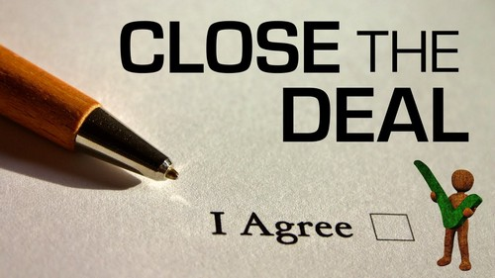In the world of sales, everyone talks about “The Close.” It’s that golden moment when the customer says “yes,” contracts are signed, and the delivery process begins. Or so we think. Far too often, we confuse winning a deal with closing it. How many times have you celebrated a verbal agreement, only to find yourself stuck weeks (or even months) later, waiting for a Purchase Order (PO) or a signed contract? Winning the deal is an essential milestone, but it’s not the finish line.

Think about how it plays out in the weekly Sales Review meeting .

**Scenario 1:** *“It’s a $250,000 deal. They’ve agreed verbally, so it should be closed by next week or the week after.”*

**Scenario 2:** *“It’s a $250,000 deal. The buyer has confirmed the agreement and told me the procurement process is underway. We’re already in their system as an approved supplier. I’m in active contact with the CFO and procurement team, ensuring paperwork is completed on schedule. Every stakeholder has agreed to the deadlines, and I’m monitoring progress closely.”* Which one sounds more solid?

The second approach demonstrates control, foresight, and a clear path to closure. If you’ve been guilty of Scenario 1, it’s time to rethink how you manage your deal closures.

**A Tale of Two Closures**

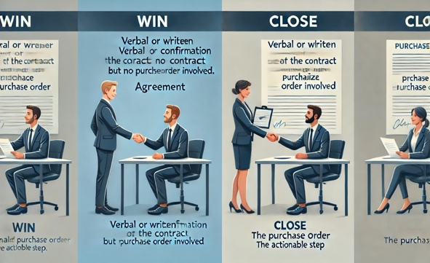Let me illustrate this with a personal story. My wife and I decided to sell our house. The offer came quickly: full asking price, no chain, cash buyer. A dream scenario. My wife started planning the move, visualizing our new home. But months later, the deal wasn’t done. The buyers had revisited the property, commissioned surveys, and started renegotiating the price. It was a stark reminder that a deal isn’t closed until it’s, well, closed! Winning the offer was just the beginning.

The same applies to sales as we think of it, in technology or whatever your offer may be. Closing begins months before the deal is “won.” It’s a process rooted in preparation, communication, and risk management.

**Building Toward Closure**

Successful sellers lay the groundwork for a smooth close well in advance. Here’s how:

* **Understand the Procurement Process Early** Ask the simple yet critical question: *“Is my company registered as a supplier in your system?”* If not, start the registration process immediately. It can take weeks, and a deal can’t close without this step.
* **Establish Deadlines Together** Work with your customer to set realistic timelines early on. If you’re in a tender or RFP process, explore the implications of delays. Ask questions like: *What happens if this timeline slips?* *Are there benefits to delivering early?* *What strategic or cost impacts would delays create?* This not only helps you qualify the deal but also positions you as a partner invested in their success.
* **Maintain Competitive Awareness** Be prepared to leverage deadlines if a competitor requests a delay. Your customer’s timeline can become a strategic advantage.
* **Create a Sales Risk Register** This might sound formal, but it’s invaluable. Identify and document potential risks to closing the deal. Ask yourself: *Could the budget be reassigned?* *Are there other projects competing for these funds?* *Do we know and have we engaged the decision-makers?* *Is there urgency, or could this be postponed without consequence?* By proactively addressing risks, share them with your buyer, and you’re less likely to be blindsided by last-minute obstacles.

**The Difference Between Winning and Closing**

Winning a deal doesn’t guarantee closure. I’ve seen deals drag out for 22 months after being “won,” and others that fell through entirely on the day the PO was expected. These situations are avoidable if you approach sales with discipline and foresight. And you have ensured that EVERYONE knows the value of doing business. Study every factor—timelines, budget, stakeholder engagement, and potential delays. Be your own devil’s advocate. Take a moment to ask yourself, *“What could go wrong?”* Address those risks early to ensure a seamless close.

**Lessons Learned**

Closing a deal often involves overcoming last-minute surprises. The best sellers anticipate these and prepare for them. Here’s how:

* **Ask Difficult Questions** Challenge your assumptions about the deal. Seek clarity on budgets, decision-makers, and urgency.
* **Be Proactive** Take control of timelines and ensure all stakeholders are aligned. This reduces the risk of delays or misunderstandings.
* **Balance Confidence with Caution** Even when everything looks perfect, step back and reassess. What could derail the process?

**Conclusion: Selling Is a Craft** ( even though we’d like it to be a science )

Closing the deal isn’t just about crossing the finish line; it’s about ensuring the race was run smoothly. The principles shared in this Trilogy—*Selling Power, Customer Focus, and Risk Awareness*—are all part of mastering the sales process. Selling isn’t a science, but it is a craft. While techniques like SPIN Selling and Challenger Sale offer useful frameworks, the magic happens when you combine these tools with genuine intent, resilience, and a willingness to learn. The best salespeople are those who bring personality and character to their work. They stay engaged, committed, and personable, turning challenges into opportunities. In the end, sales is a journey of discovery—for both you and your customer. It’s demanding, sometimes unpredictable, but always rewarding when you share the goals. Approach it with curiosity and discipline, and you’ll not only close deals but build relationships and create lasting impact. That’s the real win.